# Lab 9: Responding to an Event

## Objectives

*  Add a button
*  Handle the click event

## Steps

### Add a button

1. **Open** the **file** src\projects\ProjectCard.js
2. **Add** an **edit button** to the ProjectCard using the HTML snippet below.

*<!-- place this below the <p>Budget: ...</p> -->*

<button class="bordered">

<span class="icon-edit "></span>

Edit

</button>

Remember you will need to change some things about the HTML to make it valid JSX

#### src\projects\ProjectCard.js

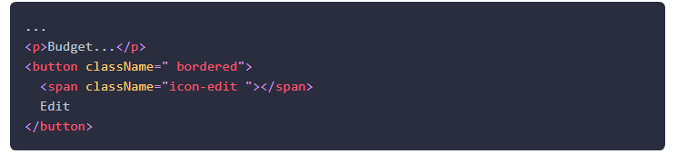

1. **Verify** the **button** **displays** in your browser.

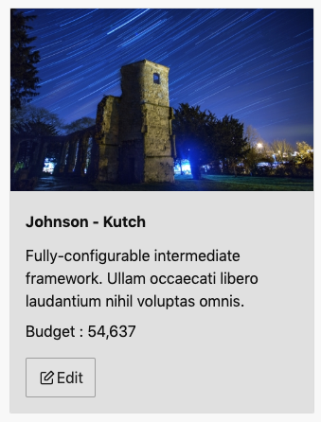

### Handle the click event

1. **Add** a handleEditClick **event handler** to ProjectCard that takes a project as an argument and logs it to the console.

#### src\projects\ProjectCard.js

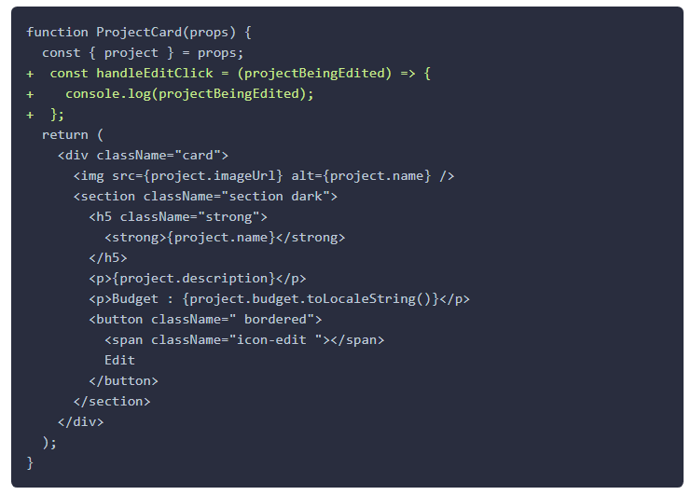

1. **Wire** up the **click** **event** of the edit button to the handleEditClick event handler.

#### src\projects\ProjectCard.js

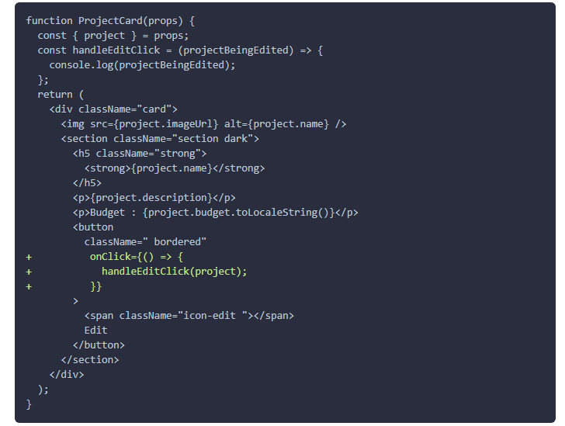

3) **Verify** the application is **working** by following these steps:

1. **Open** the application in your browser and refresh the page.
2. **Open** the Chrome DevTools to the console (F12 or fn+F12 on laptop).
3. **Click** the edit **button**.
4. **Verify** the project is logged to the Chrome DevTools console.

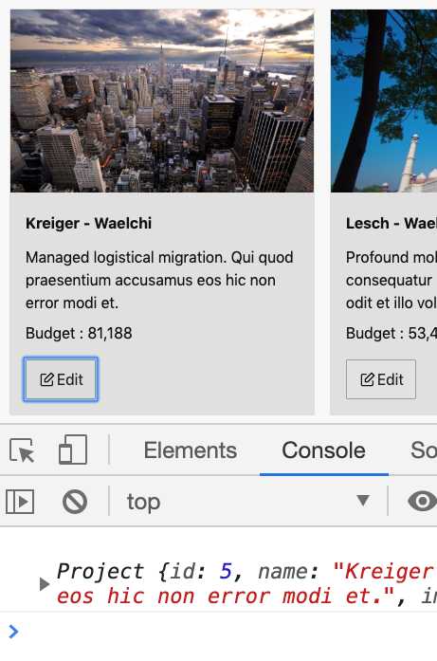

### ✔ You have completed Lab 9